**Interest Posting**

**T Code:** FPINTM1

Step 1: Navigate to Interest Run screen using the T Code and create a new Interest Run

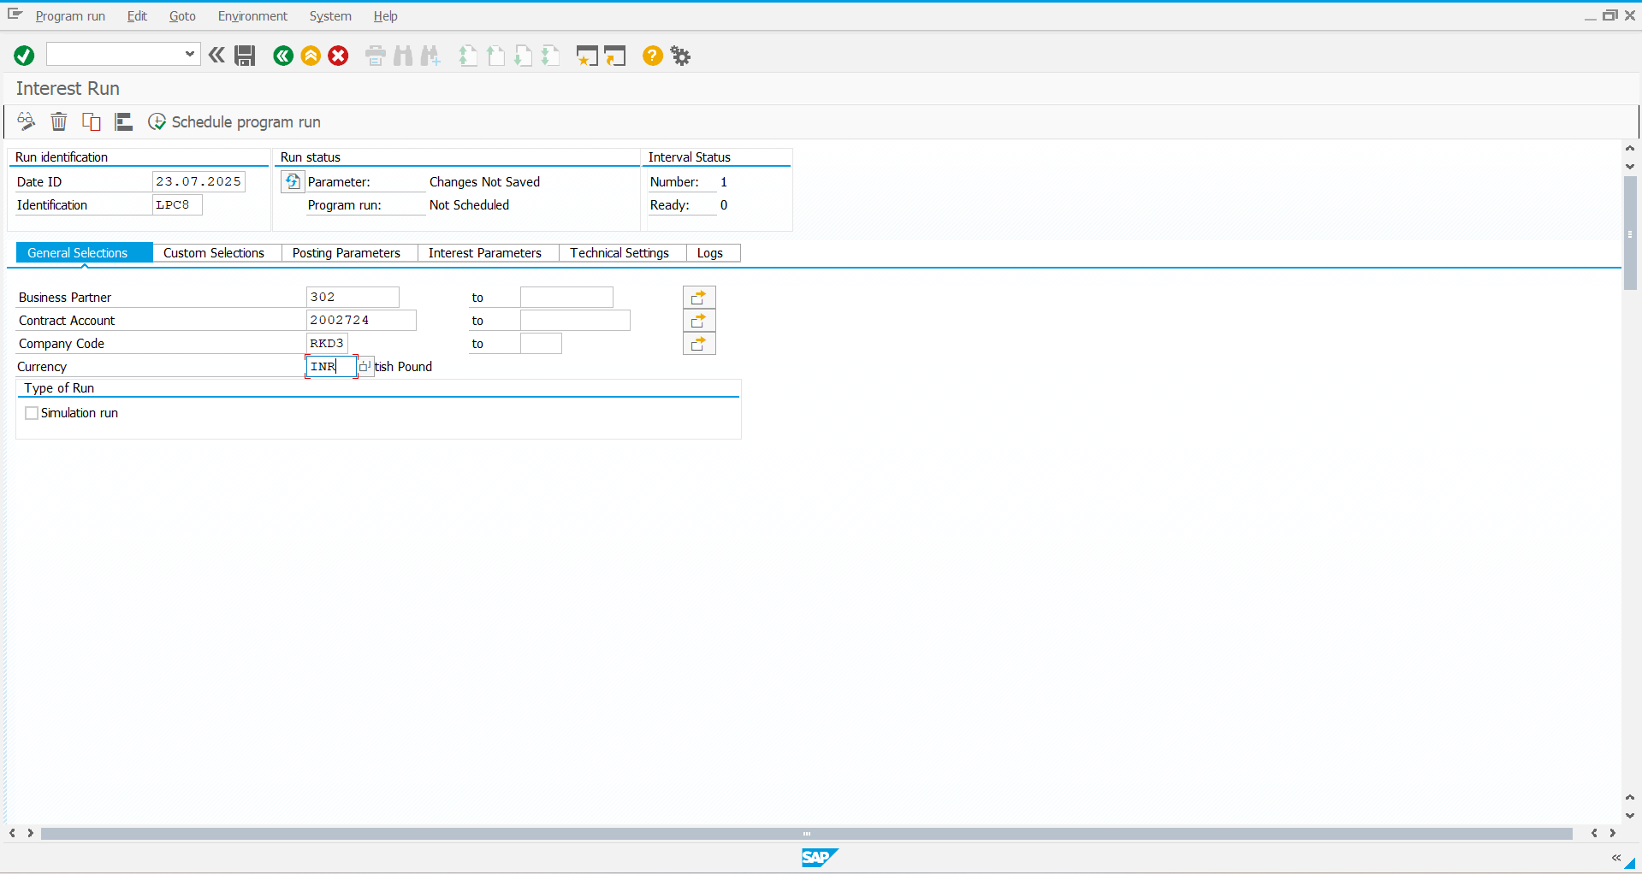

Step2: Define the Posting Parameters

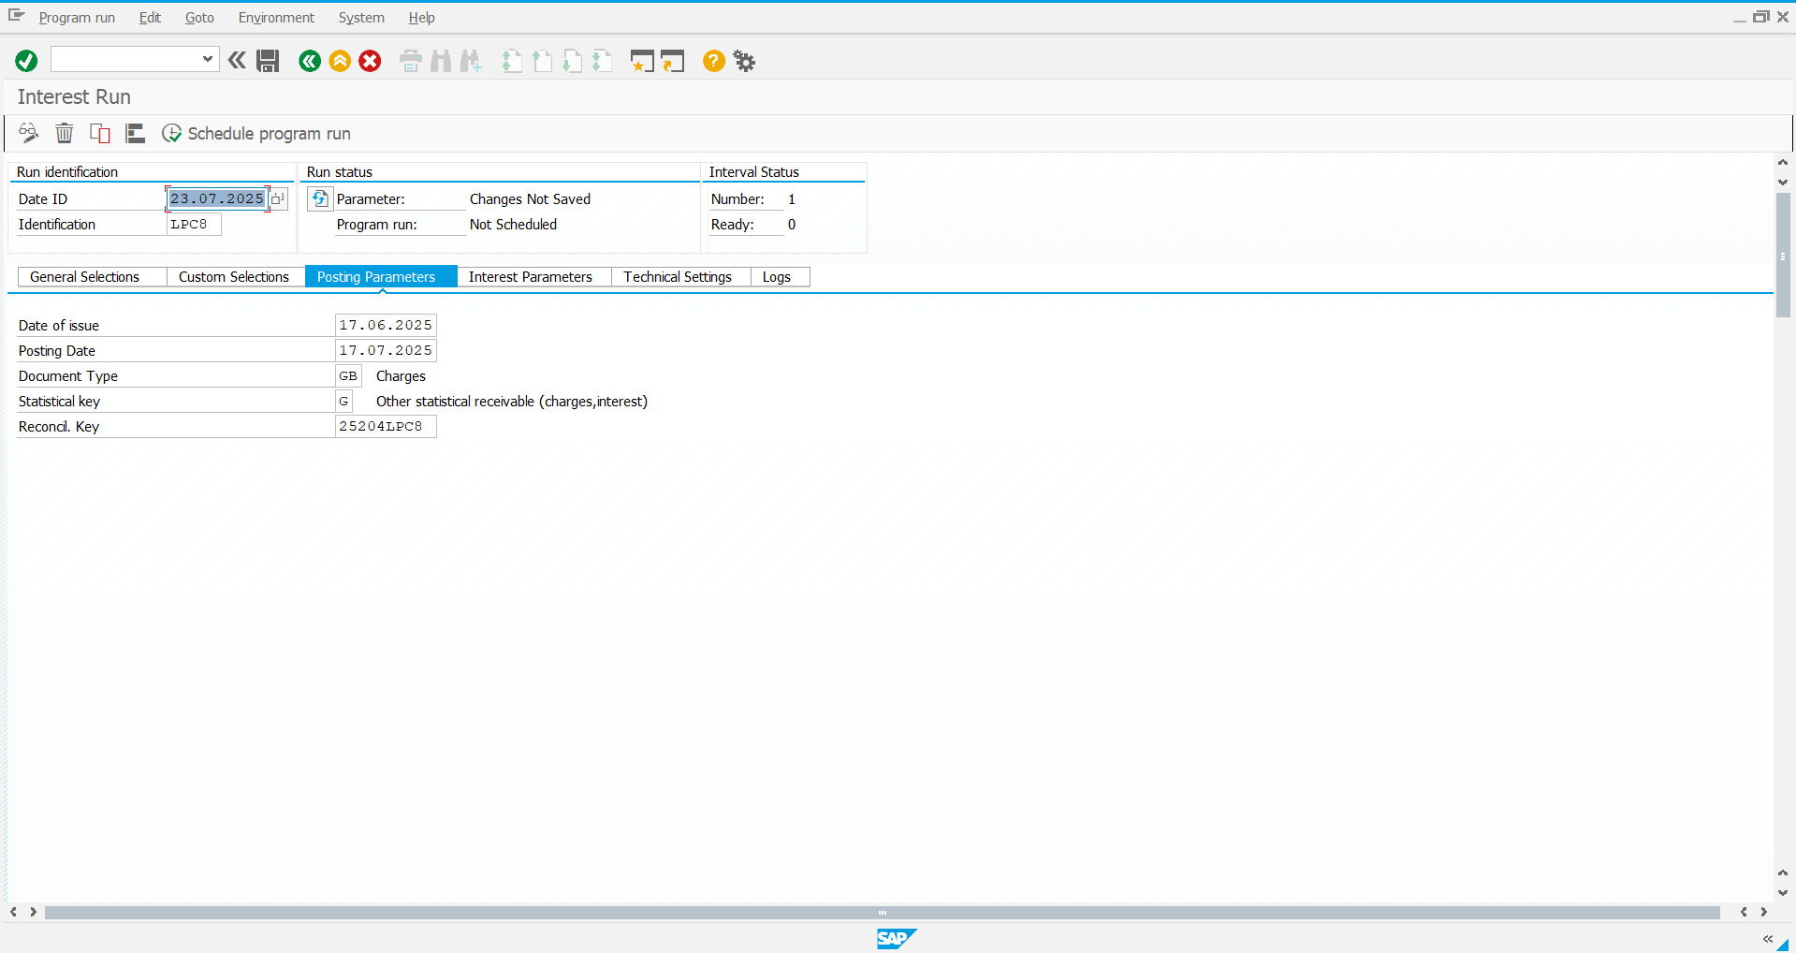

Step 3: Define the Interest Parameters and save it

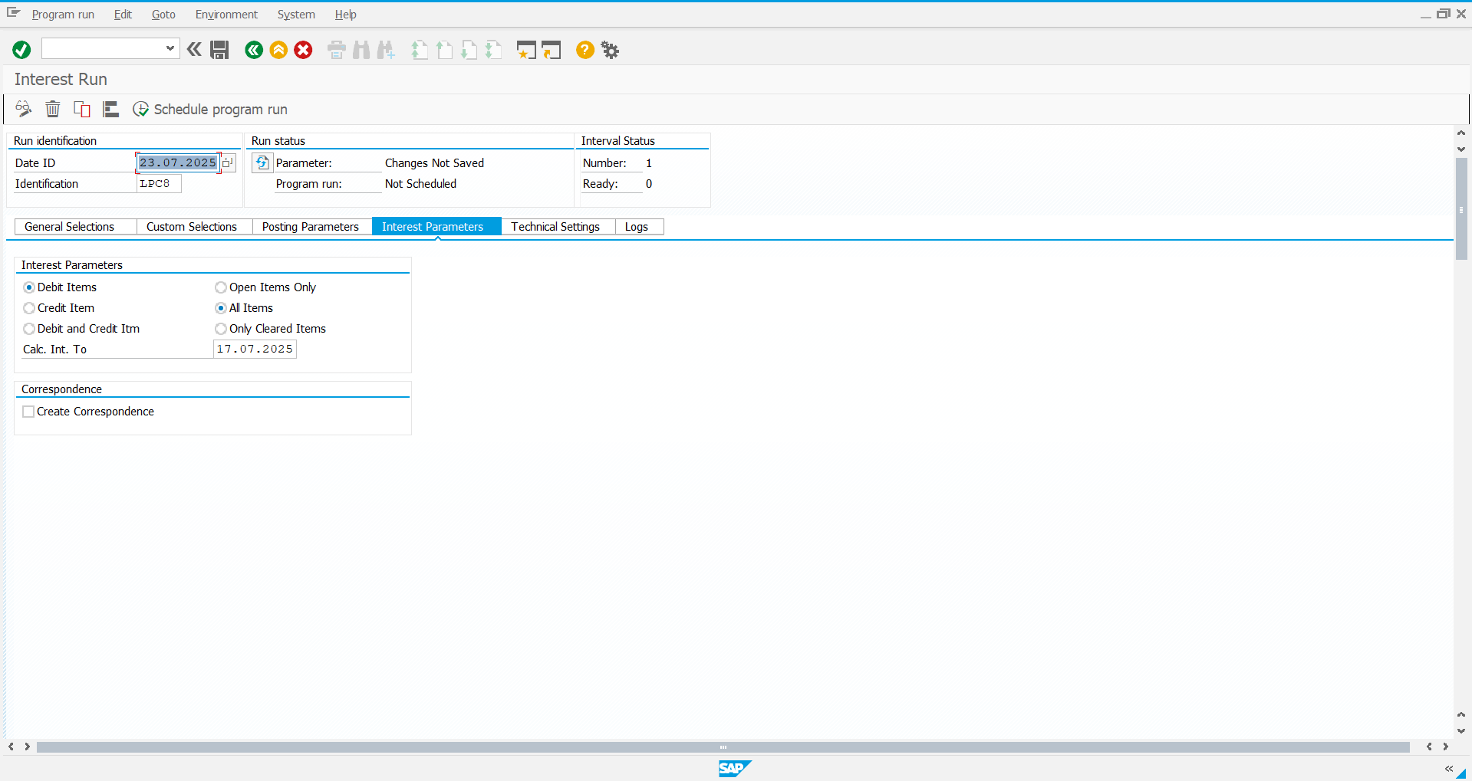

Step 4: You can see below the Parameters are saved

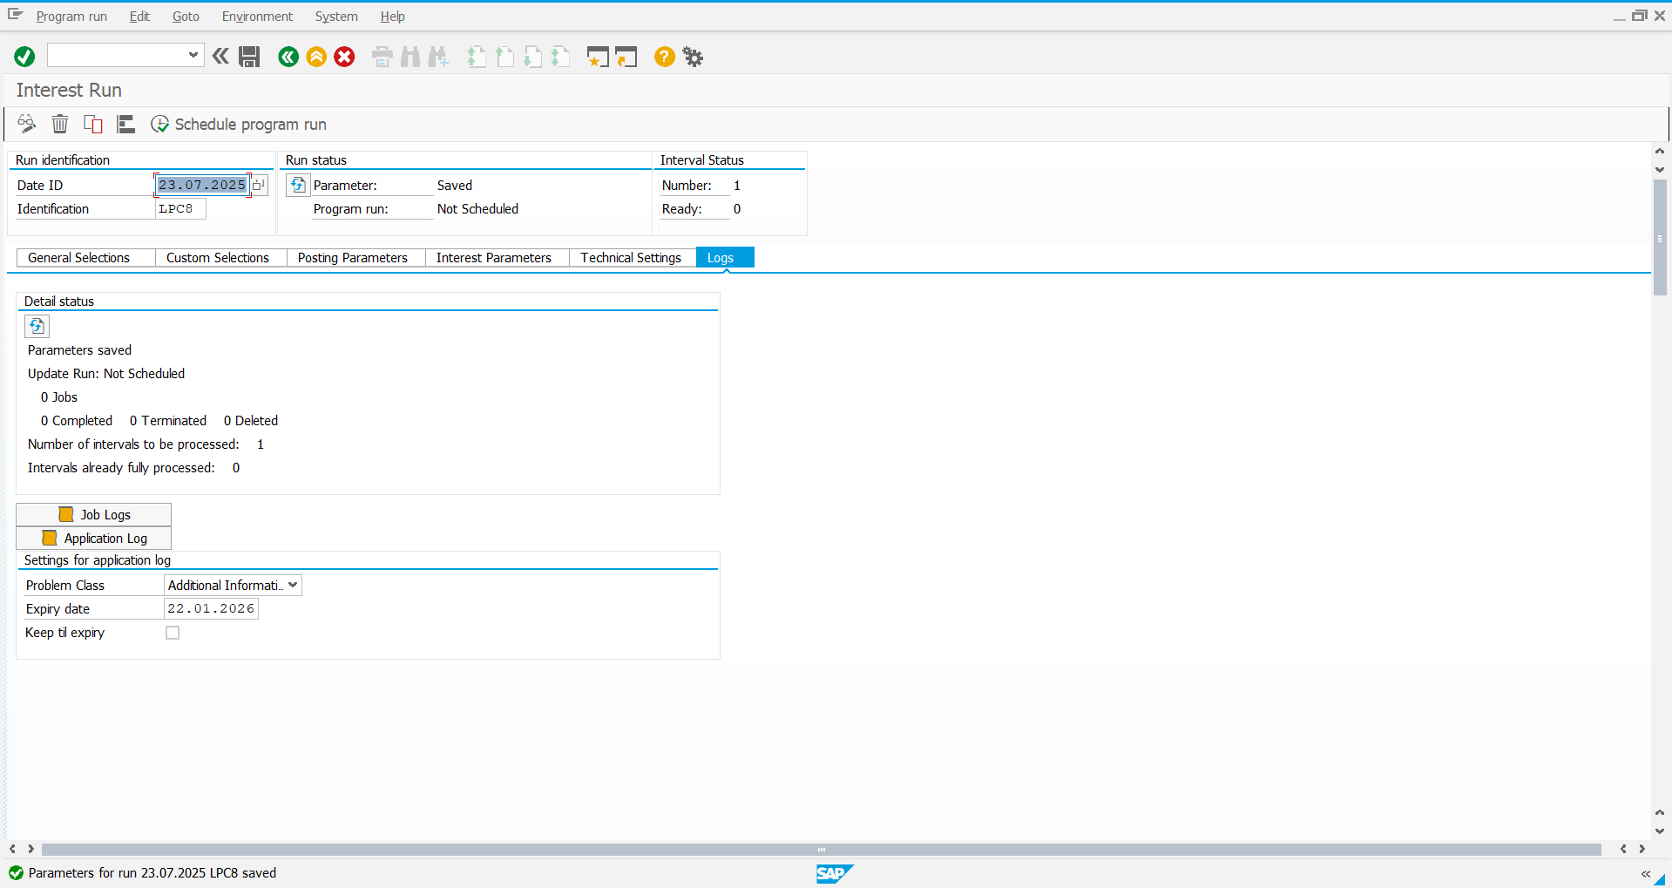

Step 5: Schedule the program Run

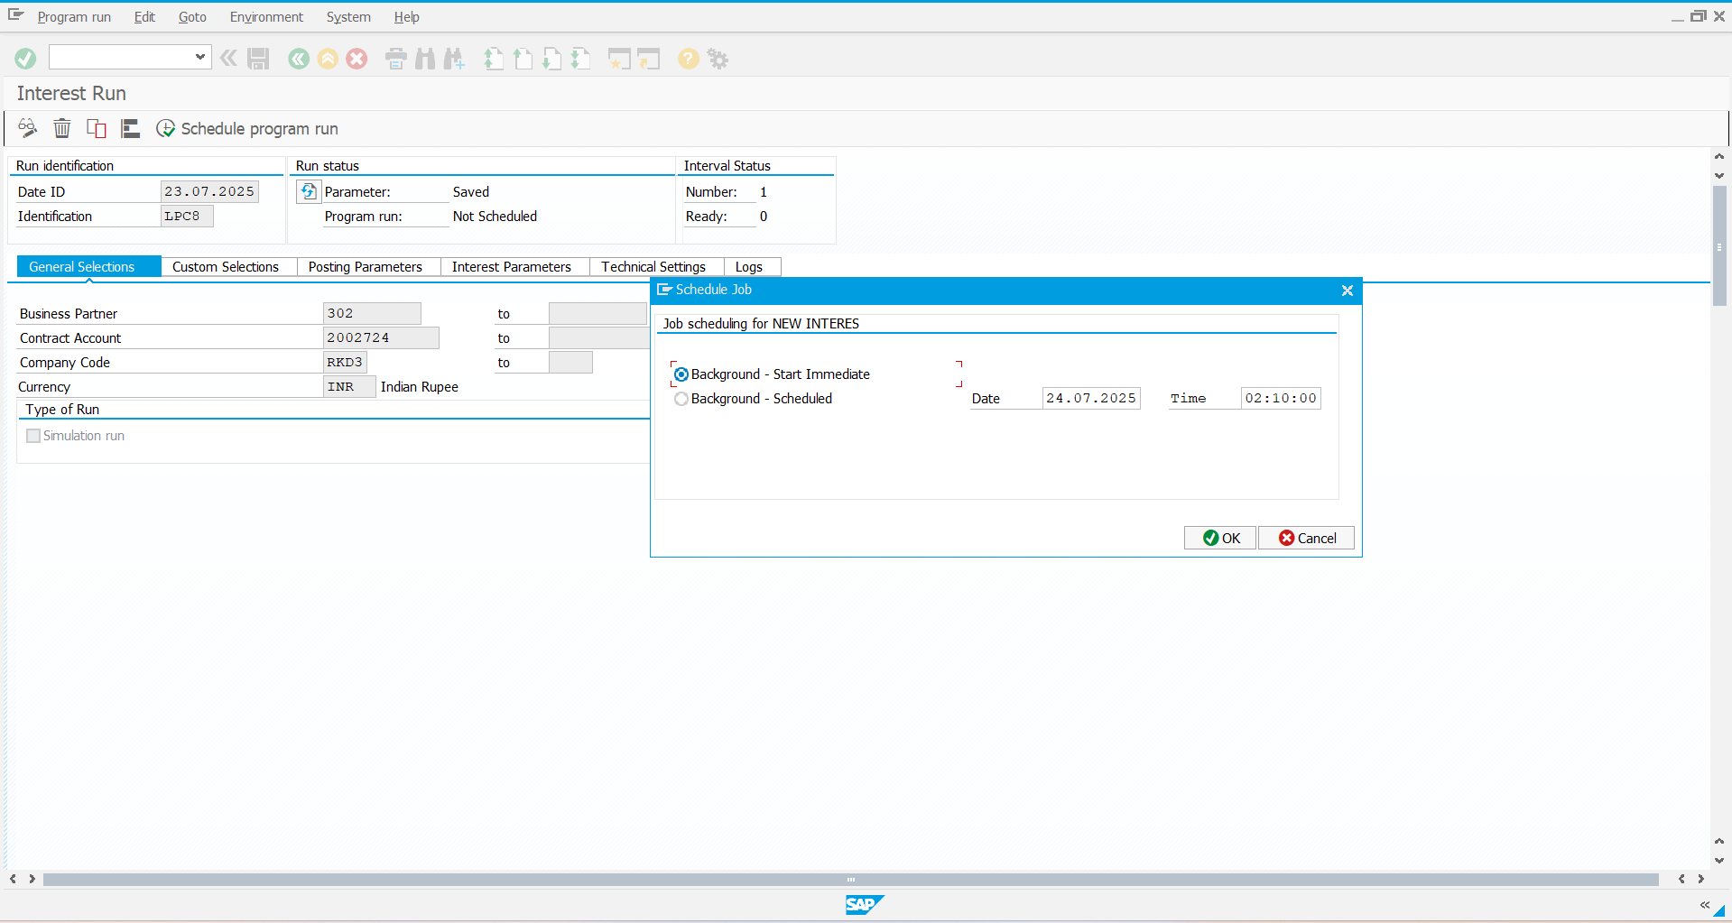

Step 6: Program Run Scheduled

